

**Planning**

**Proposal**

**Prepared by**

**Wingecarribee Shire Council**

**Strategic Planning**

**mail@wsc.nsw.gov.au**

**02 4868 0888**

Version 2.0 – For Gateway Determination

November 2019

**Planning**

**Civic Centre, 68 Elizabeth St, Moss Vale, NSW 2577.**

**PO Box 141, Moss Vale. ABN 49 546 344 354**

**T. (02) 4868 0888 E. mail@wsc.nsw.gov.au**

To amend Wingecarribee Local Environmental Plan 2010 to reclassify part of Lot 38 DP 882935, Rowland Road, Bowral, from Community to Operational to provide an access road to the proposed Southern Highlands Regional Art Gallery.

|  |
| --- |
| **DOCUMENTS ACCOMPANYING THIS PLANNING PROPOSAL** |

|  |  |
| --- | --- |
| 1 | Report to Council 25 September 2019 |
| 2 | Resolution of Council 25 September 2019 |
| 3 | Statement of Environmental Effects submitted with DA20/0272 |
| 4 | Traffic Report submitted with DA20/0272 |
| 5 | Deposited Plan |
| 6 | Certificate of Title |

|  |
| --- |
| **LOCAL GOVERNMENT AREA : WINGECARRIBEE SHIRE COUNCIL** |

|  |
| --- |
| **ADDRESS OF LAND – ROWALD ROAD BOWRAL** |
| **Figure 1: Shire Context Location Map** |
| **Figure 2: Bowral Locality Map** |
| **Figure 3:** **Location Map** |

|  |
| --- |
| **SITE LOCATION & DESCRIPTION** |

At the Extraordinary Meeting of Council of 19 September 2018, Council resolved to provide in-principle support for the construction of a Regional Art Gallery.

In order to enable consideration of the location of the Regional Art Gallery in the Old Dairy on the Retford Park Estate, an Item of Local Heritage under WLEP 2010 now owned by the NSW Branch of the National Trust of Australia, an approximate route for a public access road has been identified. **Figure 2** above indicates the location of Retford Park and the approximate proposed access way.

It is envisaged that the proposed road reserve would ultimately accommodate a new 7 metre wide rural road with flat edge treatment, i.e. no kerb and gutter, in order to be sympathetic to the local rural landscape. It is also envisaged that a separate footpath would extend northward from the existing footpath which runs along the northern edge of Rowland Road. The Traffic Report which accompanies the Planning Proposal provides more detail.

The land over which most of the proposed road will pass is identified as Lot 38 DP 882935, Rowland Road Bowral, located to the east of the David Wood Playing Fields at East Bowral. The land forms part of an area of extended unstructured public open space between the East Bowral residential area to the south and the Heritage listed Retford Park to the north.

The land was dedicated to Council as part of the East Bowral Residential area and was acquired as public reserve upon registration of Deposited Plan 882935 on 3 February, 1999. There is also a notation on the Certificate of Title for Lot 38 in the second schedule which states *‘2.The land within described is public reserve.’*

It is further noted that the Certificate of Title also identifies easements for water supply, drain water, services and access. The land is affected by a Category 2 water course which creates flood potential along its course. The land is therefore best suited to passive recreation and this is the primary use for the land. A copy of DP 882935 and the Certificate of Title are attached.

**Figure 3** above shows the location of Lot 38 and the approximate location of the proposed access road extending from the intersection of Jonathan Street and Rowland Road into the Retford Park Estate.

The subject land is Council owned and classified as ‘community’ under the provisions of s25 and s26 of the *Local Government Act 1993*. It is noted that ‘community’ land is land used for a public purpose while ‘operational’ land is land which facilitates the functions or ‘operations’ of Council.

The proposed road is not be a permitted use for ‘community’ land and therefore, the section of land required for the proposed access road needs to be reclassified to ‘operational’.

To achieve this outcome and to isolate the section of land required for the public road reserve it is intended to create a separate lot (Lot 3) as indicated in **Figure 4** below. A Development Application (DA 20/0272) to create the three (3) lot subdivision of Lot 38 was lodged with Council in early September 2019.

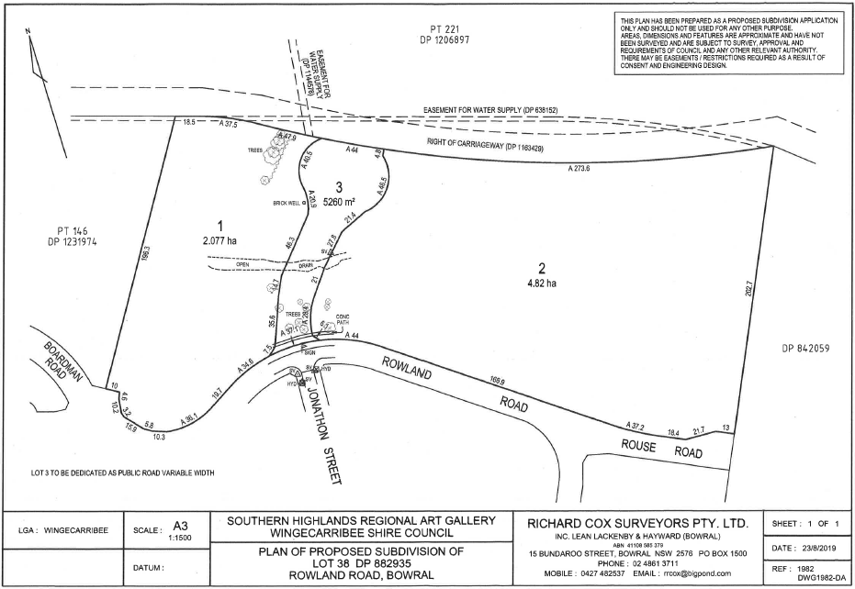

**Figure 4 Plan of Proposed Subdivision**

The DA was notified in accordance with Council’s Notification of Development Proposals Policy and no submissions were received. The Development Application approval was finalised on 1 October 2019.

It is not intended to reclassify all of Lot 38, but only that portion required for the proposed access way. The remaining portions to either side of the road reserve (Lots 1 and Lot 2 respectively) under the proposed subdivision will remain classified as ‘community’ land.

All three lots will remain zoned RE1 Public Recreation, as indicated in **Figure 5** below, because roads are permitted with consent in the RE1 zone.

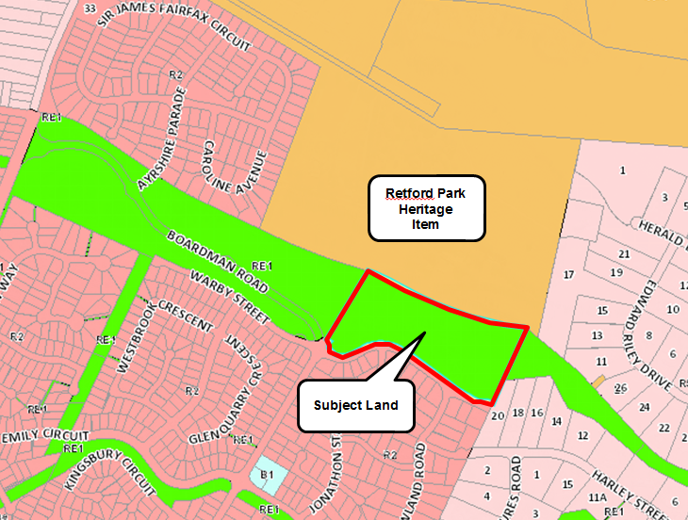

**Figure 5 Zoning of Council Land over which access road will pass**

It is intended that the access road would remain in Council ownership and would be declared a public road up to the boundary of the Retford Park boundary, at which time it would be a private road. As such, the road would need to be constructed to a public road standard in accordance with Council requirements. The ‘*public reserve*’ status over Lot 3 would also be removed, but would remain over Lots 1 and 2.

Although the land is affected by an easement and right of access as indicated on the Certificate of Title, Council is not seeking to discharge any interests over the land.

The land is currently used for passive recreation. As **Figure 3** above indicates the area of the proposed across road is mostly clear of vegetation. A ‘street view’ image of the area is shown at **Figure 6** below. It is noted that a paved walkway is located along the southern edge of the public reserve, as indicated on the Certificate of Title, providing all weather pedestrian access.

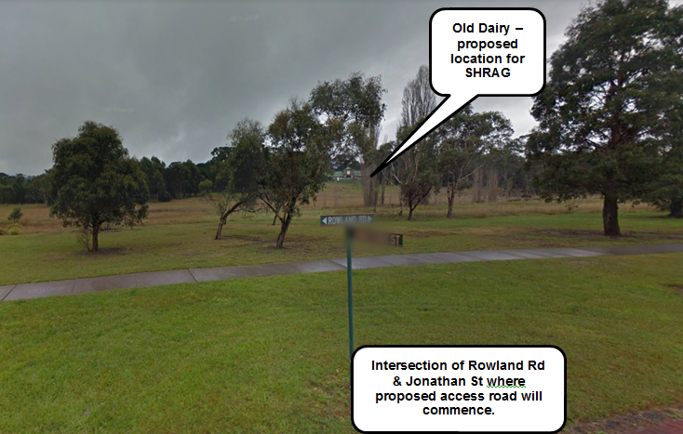**Figure 6 Street view of proposed access road location**

The purpose of the proposed road is to provide access to a valuable community resource and public asset, namely a Regional Art Gallery. Without the proposed road, access to this resource may not be possible, therefore a genuine public purpose underpins the proposed road access way.

At its Ordinary Meeting of 25 September 2019 Council unanimously resolved as follows:

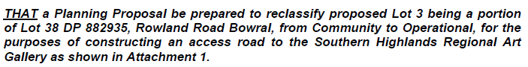

The ‘Attachment 1’ referenced in the resolution is reproduced as **Figure 4** above. The purpose of this Planning Proposal is to commence the reclassification process.

|  |
| --- |
| **PART 1 : OBJECTIVES OR INTENDED OUTCOMES** |

The intended outcome of this Planning Proposal is to reclassify the portion of Lot 38 DP 882935 identified as Lot 3 in **Figure 4** above from ‘community’ to ‘operational’ in order to provide for an access road to the proposed Southern Highlands Regional Art Gallery. The remaining portions of Lot 38 (shown as Lot 1 and Lot 2 in **Figure 4** above) will remain classified as ‘community’. All three lots will remain rezoned RE1 Public Recreation.

|  |
| --- |
| **PART 2 : EXPLANATION OF THE PROVISIONS** |

* To achieve the intended outcomes of the Planning Proposal the following amendments to the WLEP 2010 instrument will be required:
* Insert the newly created Lot 3 into *Schedule 4 (Classification and reclassification of public land) Part 2 (Land classified, or reclassified*, as *operational land – interests changed*) as required under *clause 5.2 of WLEP 2010*. The DA to progress the subdivision process has been approved by Council and the correct legal description for ‘Lot 3’ is expected to be available by the time the Planning Proposal is finalised. Once the DA has been finalised, the cadastre will be updated and a new legal description for the subject land created. These will be used to amend both the WLEP 2010 instrument and relevant map.
* To achieve the intended outcomes of the Planning Proposal the following WLEP 2010 map will require amendment:

|  |  |
| --- | --- |
| **Map to be Amended** |  |
| Land Reclassification (Part Lots) Map | Sheet RPL_007A |

|  |
| --- |
| **PART 3 : JUSTIFICATION OF OBJECTIVES, OUTCOMES & PROCESS** |

|  |
| --- |
| **Section A – Need for the Planning Proposal** |

1. **Is the Planning Proposal a result of any strategic study or report?**

The Planning Proposal is in response to a proposal to locate the Southern Highlands Regional Art Gallery within the Old Dairy on the Retford Park Estate, an Item of Local Heritage owned by the NSW Branch of the National Trust of Australia.

As explained in the introduction, the land over which most of the proposed road will pass forms part of an area of extended unstructured public open space between the East Bowral residential area to the south and Retford Park to the north. The land is affected by a Category 2 water course which creates flood potential along its course.

The land is therefore best suited to passive recreation and this is the primary use for the land. The area is grassed with few trees with no recreation structures within it. It is noted that a paved walkway is located along the southern edge of the public reserve providing all weather pedestrian access.

The land is mainly utilised by local residents for walking, principally for exercise as the land does not provide any key connection to shops or services. The purpose of the proposed road is to provide access to a valuable community resource and public asset, namely a Regional Art Gallery. Without the proposed road, access to this resource may not be possible, therefore a genuine public purpose underpins the proposed road access way.

A Traffic report accompanies the Planning Proposal which indicates that the subject land represents a good access option, being the most direct route to the proposed art gallery which does not take traffic directly through residential areas. The style of the proposed road is intended to be low impact.

1. **Is the Planning Proposal the best means of achieving the objectives or intended outcomes, or is there a better way?**

Because WLEP 2010 needs to be amended as described above, a Planning Proposal is the only means of achieving the intended outcome.

|  |
| --- |
| **Section B – Relationship to strategic planning framework** |

1. **Is the Planning Proposal consistent with the objectives and actions contained within the applicable regional or sub-regional strategy (including draft strategies)?**

The Wingecarribee Shire is within the Sydney South East and Tablelands region. One of the key advantages of locating the Southern Highlands Regional Art Gallery in the Old Dairy of Retford Park is that it will help conserve and utilise this local item of heritage significance in keeping with Direction 23 – Protect the region’s heritage and would contribute in a broader sense to the Goal of providing healthy and connected communities through opportunities to experience public art and related activities.

1. **Is the Planning Proposal consistent with a council’s local strategy or other local strategic plan?**

The Wingecarribee Local Planning Strategy 2015-2031 was adopted by Council on 23 March 2015 and conditionally endorsed by the Department of Planning and Environment on 15 May 2017. The Local Planning Strategy supports the Regional Plan in seeking ways to preserve Items of Heritage to the benefit of the broader community.

1. **Is the Planning Proposal consistent with applicable State Environmental Planning Policies?**

The Proposal has been assessed against relevant SEPPs as indicated below.

| **SEPP** | **Relevance to Planning Proposal** |
| --- | --- |
| No.1 Development Standards | **NOT RELEVANT** – The SEPP was replaced by Clause 4.6 of WLEP2010 as the mechanism for any variation to development standards. |
| No.19 Bushland in Urban Areas | **NOT RELEVANT** – The SEPP does not apply to Wingecarribee Shire. |
| No.21 Caravan Parks | **CONSISTENT** – the Planning Proposal applies to land which is within the RE1 Public Recreation where caravan parks are permitted with consent. However the intent of the Planning Proposal is reclassify a portion of the land from ‘community’ to ‘operational’ to enable an access road to the proposed Southern Highlands Regional Art Gallery to be permitted with consent. |
| No.33 Hazardous and Offensive Development | **CONSISTENT** – The Planning Proposal applies to land within the RE1 Public Recreation zone in which hazardous and offensive industries are prohibited. |
| No.36 Manufactured Home Estates | **NOT RELEVANT** – The SEPP does not apply to land within a water catchment (as prescribed by Schedule 2 of the SEPP). The Planning Proposal only applies to land within the Sydney Drinking Water Catchment area and, therefore, the SEPP does not apply. |
| No.44 Koala Habitat Protection | **CONSISTENT** – The subject land is not identified as core koala habitat. |
| No. 47 Moore Park Showground | **NOT RELEVANT** – The SEPP does not apply to Wingecarribee Shire. |
| No.50 Canal Estate Development | **CONSISTENT** – The Planning Proposal does not apply to an existing canal estate development. |
| No.55 Remediation of Land | **CONSISTENT** – The Planning Proposal does not apply to land that is or likely to be contaminated, therefore the SEPP is not applicable. |
| No.64 Advertising and Signage | **CONSISTENT** – The Planning Proposal does not apply to signage. Any subsequent road signage would be assessed as part of any subsequent Development Application for an access road. |
| No.65 Design Quality of Residential Apartment Development | **CONSISTENT** – The Planning Proposal does not apply to residential apartment development. |
| No.70 Affordable Housing (Revised Schemes) | **NOT RELEVANT** – The SEPP does not apply to Wingecarribee Shire. |
| Aboriginal Land 2019 | **NOT RELEVANT** – The SEPP does not apply to Wingecarribee Shire. |
| Affordable Rental Housing 2009 | **CONSISTENT** – The Planning Proposal does not apply to any residential development. |
| Building Sustainability Index: BASIX 2004 | **CONSISTENT** – The Planning Proposal does not affect the application of this SEPP. |
| Coastal Management 2018 | **NOT RELEVANT** – The SEPP does not apply to Wingecarribee Shire. |
| Concurrences 2018 | **CONSISTENT** – The Planning Proposal does not affect the application of this SEPP. |
| Educational Establishments and Child Care Facilities 2017 | **CONSISTENT** – The Planning Proposal does not apply to any existing educational establishments or child care facilities. Educational establishments are prohibited in the RE1 Public Recreation zone. |
| Exempt and Complying Development Codes 2008 | **CONSISTENT** – The Planning Proposal does not apply to any development applicable under this SEPP. |
| Gosford City Centre 2018 | **NOT RELEVANT** – The SEPP does not apply to Wingecarribee Shire. |
| Housing for Seniors or People with a Disability 2004 | **NOT RELEVANT** – The SEPP does not apply to environmentally sensitive land of which a water catchment is included (Schedule 1). The subject land is within the Sydney Drinking Water Catchment area and, therefore, the SEPP does not apply. |
| Infrastructure 2007 | **CONSISTENT** – intent of the Planning Proposal is to reclassify a portion of Council owned ‘community’ land to enable a development application for a public road to be considered by Council. The provisions of this SEPP would be considered if relevant at the time of assessing the road application itself. |
| Kosciuszko National Park—Alpine Resorts 2007 | **NOT RELEVANT** – The SEPP does not apply to Wingecarribee Shire. |
| Kurnell Peninsula 1989 | **NOT RELEVANT** – The SEPP does not apply to Wingecarribee Shire. |
| Mining, Petroleum Production and Extractive Industries 2007 | **CONSISTENT** – The Planning Proposal does not affect the application of this SEPP. |
| Miscellaneous Consent Provisions 2007 | **CONSISTENT** – The Planning Proposal does not affect the application of this SEPP. |
| Penrith Lakes Scheme 1989 | **NOT RELEVANT** – The SEPP does not apply to Wingecarribee Shire. |
| Primary Production and Rural Development 2019 | **CONSISTENT** – The Planning Proposal applies to RE1 Public recreation zoned land and therefore the SEPP does not apply. |
| State and Regional Development 2011 | **CONSISTENT** – The Planning Proposal does not affect the application of this SEPP. |
| State Significant Precincts 2005 | **CONSISTENT** – The Planning Proposal is not within one of the State significant precincts covered by this SEPP. |
| Sydney Drinking Water Catchment 2011 | **CONSISTENT** – The Planning Proposal does not affect the application of this SEPP. The Planning Proposal will be referred to Water NSW for comment prior to being placed on public exhibition. |
| Sydney Region Growth Centres 2006 | **NOT RELEVANT** – The SEPP does not apply to Wingecarribee Shire. |
| Three Ports 2013 | **NOT RELEVANT** – The SEPP does not apply to Wingecarribee Shire. |
| Urban Renewal 2010 | **CONSISTENT** – The subject land is not within a potential urban renewal precinct identified by the SEPP, therefore the SEPP does not apply to the subject land. |
| Vegetation in Non-Rural Areas 2017 | **NOT RELEVANT** – The SEPP does not apply to Wingecarribee Shire. |
| Western Sydney Employment Area 2009 | **NOT RELEVANT** – The SEPP does not apply to Wingecarribee Shire. |
| Western Sydney Parklands | **NOT RELEVANT** – The SEPP does not apply to Wingecarribee Shire. |

1. **Is the Planning Proposal consistent with applicable Section 9.1 Directions?**

The Planning Proposal has been assessed against applicable Directions issued by the Minister for Planning under *section 9.1 of the Environmental Planning & Assessment Act 1979*. These assessments are reproduced below. Directions not applicable to Wingecarribee Shire have been excluded.

| 1. **Employment & Resources** | **Assessment** |
| --- | --- |
| **1.1 Business & Industrial Zones** | **CONSISTENT**  The Planning Proposal applies to existing RE1 Public Recreation zoned land and, therefore, does not affect employment lands. |
| **1.2 Rural Zones** | **CONSISTENT**  The Planning Proposal applies to existing RE1 Public Recreation zoned land and, therefore, does not affect agricultural production on rural lands. |
| **1.3 Mining, Petroleum Production & Extractive Industries** | **CONSISTENT**  The Planning Proposal does not seek to alter any existing opportunities for mining, petroleum production or extractive industries. |
| **1.4 Oyster Aquaculture** | **CONSISTENT**  The Planning Proposal does not apply to a Priority Oyster Aquaculture Area. |
| **1.5 Rural Lands** | **CONSISTENT**  The Planning Proposal does not affect any rural lands as it applies to existing RE1 Public Recreation zoned land and does not propose a change of zoning. |

| 1. **Environment & Heritage** | **Assessment** |
| --- | --- |
| **2.1 Environment Protection Zones** | **CONSISTENT**  The Planning Proposal does not affect any environmental protection zones as it applies to existing RE1 Public Recreation zoned land and does not propose a change of zoning. |
| **2.2 Coastal Management** | **CONSISTENT**  The Planning Proposal does not apply to a coastal area, being within the township of Bowral, NSW. There are no coastal areas within the Wingecarribee Shire Council. |
| **2.3 Heritage Conservation** | **CONSISTENT**  The Planning Proposal relates to the potential use of Retford Park, an Item of Local Heritage listed in Schedule 5 of WLEP 2010, for the purposes of a Regional Art Gallery, a use which would assist in the conservation of the heritage item in accordance with this Direction. |
| **2.4 Recreation Vehicle Areas** | **CONSISTENT**  The Planning Proposal does not seek to enable land to be developed for a recreation vehicle area. |

| 1. **Housing, Infrastructure & Urban Development** | **Assessment** |
| --- | --- |
| **3.1 Residential Zones** | **CONSISTENT**  The Planning Proposal does not affect land for residential development or housing choice. |
| **3.2 Caravan Parks & Manufactured Home Estates** | **CONSISTENT**  The Planning Proposal does not identify land suitable for caravan parks nor alter existing opportunities for caravan park development. |
| **3.3 Home Occupations** | **CONSISTENT**  The Planning Proposal does not alter the existing opportunities for home occupations on the subject land, which may be carried out without development consent in the R2 Low Density Residential zone. |
| **3.4 Integrating Land Use & Transport** | **CONSISTENT**  The Planning Proposal seeks to provide an opportunity for an access road to the proposed Regional art Gallery to be considered and does not alter or remove zones or any provisions relating to the existing R2 Low Density Residential zoned land. |
| **3.5 Development near Regulated Airports and Defence Airfields** | **CONSISTENT**  The land subject to the Planning Proposal is not near a regulated airport or a defence airfield. |
| **3.6 Shooting Ranges** | **CONSISTENT**  The land subject to the Planning Proposal is not in the vicinity of an existing shooting range. |
| **3.7 Reduction in non-hosted short term rental accommodation period** | **CONSISTENT**  The Planning Proposal does not seek to add, subtract or alter any provisions relating to short-term rental accommodation. |

| 1. **Hazard & Risk** | **Assessment** |
| --- | --- |
| **4.1 Acid Sulphate Soils** | **CONSISTENT**  The Wingecarribee Shire is not within an identified Acid Sulphate Soils area. |
| **4.2 Mine Subsidence & Unstable Land** | **CONSISTENT**  The land subject to the Planning Proposal is not within a mine subsidence district. |
| **4.3 Flood Prone Land** | **CONSISTENT**  The land subject to the Planning Proposal is not within a flood prone area, as identified in any flood study or within a flood planning area on the Flood Planning Area Map that forms part of the WLEP 2010. |
| **4.4 Planning for Bushfire Protection** | **CONSISTENT**  The land subject to the Planning Proposal is not identified as bushfire prone land. |

| 1. **Regional Planning** | **Assessment** |
| --- | --- |
| **5.1 Implementation of Regional Strategies** | **CONSISTENT**  This Direction applies as the Wingecarribee Shire is within the area to which the (former) Sydney–Canberra Corridor Regional Strategy applies. However, this Strategy was replaced by the South East and Tablelands Regional Plan 2036 in 2017. See statement of consistency under Direction 5.10. |
| **5.2 Sydney Drinking Water Catchments** | **CONSISTENT**  The Planning Proposal applies to land within the Sydney Drinking Water Catchment. The Planning Proposal seeks to maintain the existing zoning of the subject land. The Planning Proposal will be referred to Water NSW for comment prior to being placed on public exhibition. |
| **5.10 Implementation of Regional Plans** | **CONSISTENT**  The Planning Proposal is consistent with the current Regional Strategy—being the South East and Tablelands Regional Plan 2036—which recognises the distinctive character and heritage values in the region. Direction 23 of this plan articulates how the region’s heritage should be protected and prioritises conservation of heritage assets (action 23.3), which is consistent with the aims of this Planning Proposal. |
| **5.11 Development of Aboriginal Land Council land** | **CONSISTENT**  The land subject to the Planning Proposal does not lie within an area identified in the Land Application Map of State Environmental Planning Policy (Aboriginal Land) 2019. |

| 1. **Local Plan Making** | **Assessment** |
| --- | --- |
| **6.1 Approval & Referral Requirements** | **CONSISTENT**  The Planning Proposal does not include any new provisions nor identifies any development as designated development. |
| **3.2 Reserving Land for Public Purposes** | **CONSISTENT**  The Planning Proposal applies to public land classified as ‘community’. The intent of the Proposal is to reclassify the land as ‘operational’ to allow consideration of a public road. Therefore the use of the land remains ‘public’ although the classification will alter. |
| **6.3 Site Specific Provisions** | **CONSISTENT**  The Planning Proposal does not include any site specific provisions. |

|  |
| --- |
| **Section C – Environmental, Social & Economic Impacts** |

1. **Is there any likelihood that critical habitat or threatened species, populations or ecological communities, or their habitats, will be adversely affected as a result of the Planning Proposal?**

There are no mapped critical habitats or threatened species, populations or ecological communities located on the subject land.

1. **Are there any other likely environmental effects as a result of the Planning Proposal and how are they proposed to be managed?**

There are no likely environmental effects resulting from the Planning Proposal.

1. **Has the Planning Proposal adequately addressed any social and economic effects?**

The area of the proposed access road does intersect an existing area of RE1 Public recreation land. The location of the proposed access road also offers the opportunity for an Item of Local Heritage to be further conserved and more fully utilised. The proposed Regional Art Gallery itself seeks to contribute to social and economic benefit of the community.

|  |
| --- |
| **Section D – State and Commonwealth Interests** |

1. **Is there adequate public infrastructure for the Planning Proposal?**

Yes. The Planning Proposal will contribute to the existing public infrastructure through enabling the provision of an access road to the regional art Gallery.

|  |
| --- |
| **PART 4 – MAPPING** |

Once the Development Application to create the three lot subdivision has been finalised, the cadastre will be updated and a new legal description for the subject land created. These will be used to amend both the WLEP 2010 instrument and relevant map.

|  |  |
| --- | --- |
| **Map to be Amended** |  |
| Land Reclassification (Part Lots) Map | Sheet RPL_007A |

|  |
| --- |
| **PART 5A – AGENCY REFERRALS** |

Agency referrals will occur as directed in the Gateway Determination. However, knowing that Council will be required to refer the Planning Proposal to Water NSW, and the strong likelihood that referral will also be required to the NSW Rural Fire Service and to the Department of Premier and Cabinet (Heritage), the process of referring the Planning Proposal to these agencies has been initiated.

|  |
| --- |
| **PART 5B – COMMUNITY CONSULTATION** |

Community consultation will occur as directed in the Gateway Determination. Council normally provides 30-31 days of public exhibition, however depending on the timing of the Gateway Referral, a longer exhibition period may be provided.

The public exhibition will include notification by letter/email to affected and adjoining property owners and weekly advertising in the Southern Highland News for the duration of the exhibition period. The Planning Proposal will also be listed on Council’s What’s On Exhibition page and notification of the exhibition will included in Council E-Newsletters sent to over 3,500 recipients.

The principal place of public exhibition is the Customer Service Counter at the Civic Centre, 68 Elizabeth Street, Moss Vale, NSW 2577 and the Planning Proposal is also available for view on Council’s website and at all relevant libraries including Council’s Rural Outreach & Delivery Service (ROADS) Mobile Library.

It is also noted that a Public Hearing will be required as directed under *s57 of the Environmental Planning & Assessment Act 1979* and *s29 of the Local Government Act 1993* and must be held no earlier than 21 days after completion of the public exhibition of the Planning Proposal. It is noted that the Public Hearing is chaired by an independent facilitator who then submits a report to Council identifying any issues raised.

|  |
| --- |
| **PART 6 – TIMELINE** |

The following table indicates a likely timeline showing key milestones.

|  |  |
| --- | --- |
| **MILESTONE** | **INDICATIVE DATE** |
| Gateway Determination | January 2020 |
| Agency Consultation | January 2020 |
| Public Exhibition | February 2020 |
| Public Hearing | March 2020 |
| Report to Council on exhibition of Planning Proposal & Public Hearing | April 2020 |
| S.3.36 Documents to Department & PCO. | April 2020 |
| Approximate completion date | May 2020 |

|  |
| --- |
| **DELEGATIONS** |

As the Planning Proposal involves reclassification of public land, Council’s delegation may not be used and is not sought.